Chap 5 Programming Exercises Tyler Paulley

Exercise 2: Linking Array Items

The ordered output array printed one character at a time

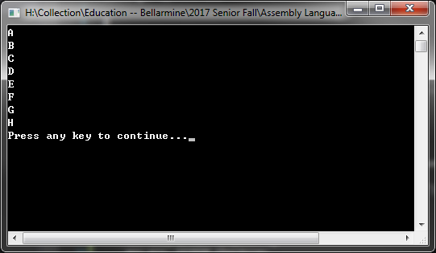

We can see the ordered output array in memory when the program finishes.

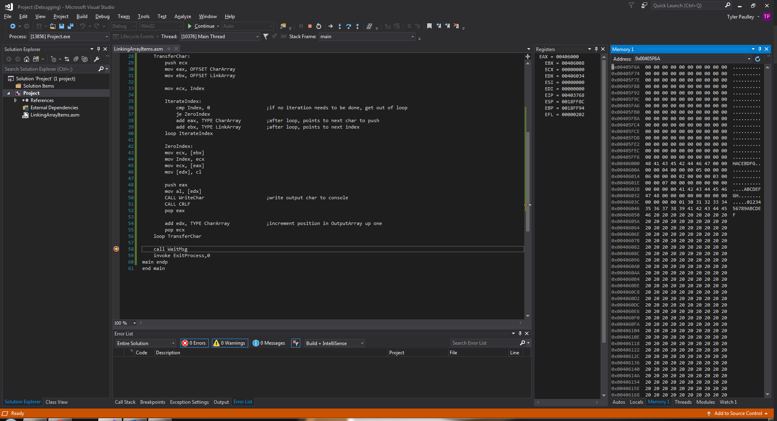

Exercise 4: Simple Addition (2)

The outputs from a sample run of the code is show below. The screen is cleared after every addition.

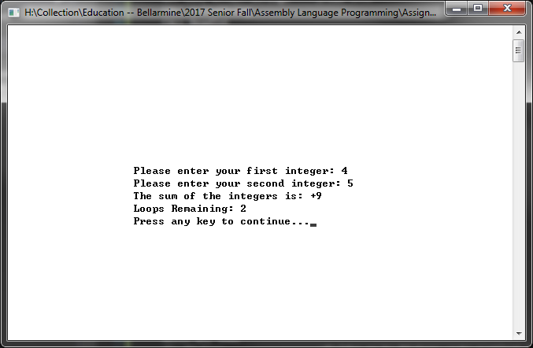

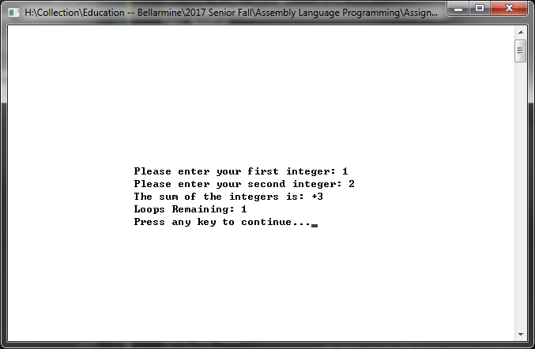

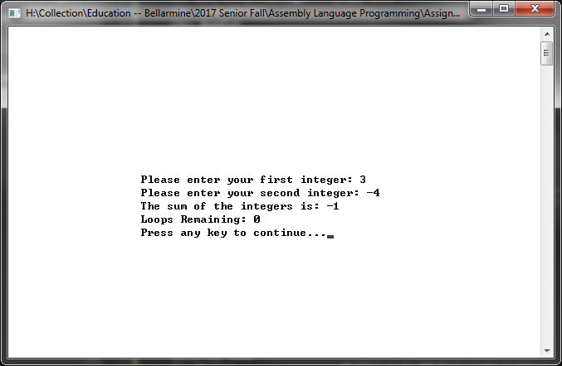

Exercise 5: Better Random Range

The random numbers from two sample runs are show below.

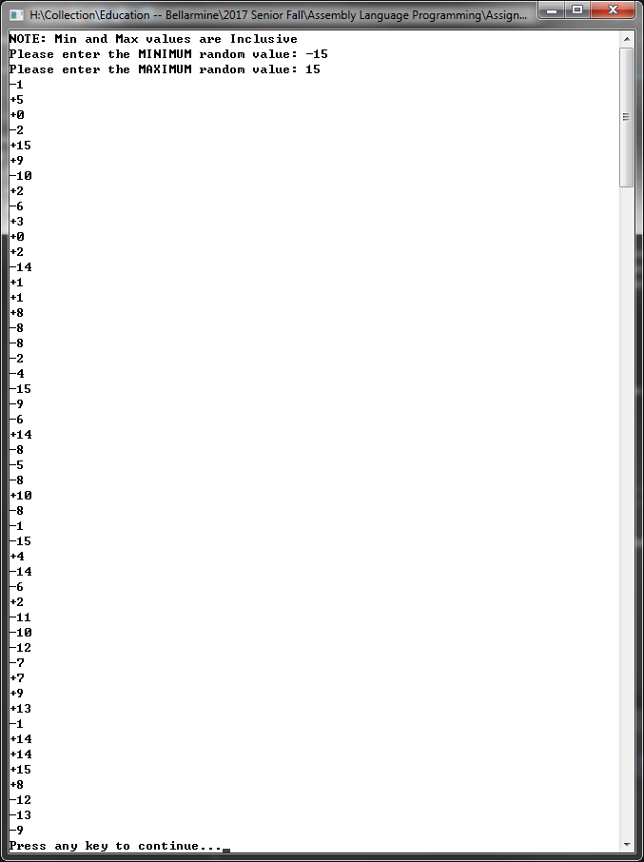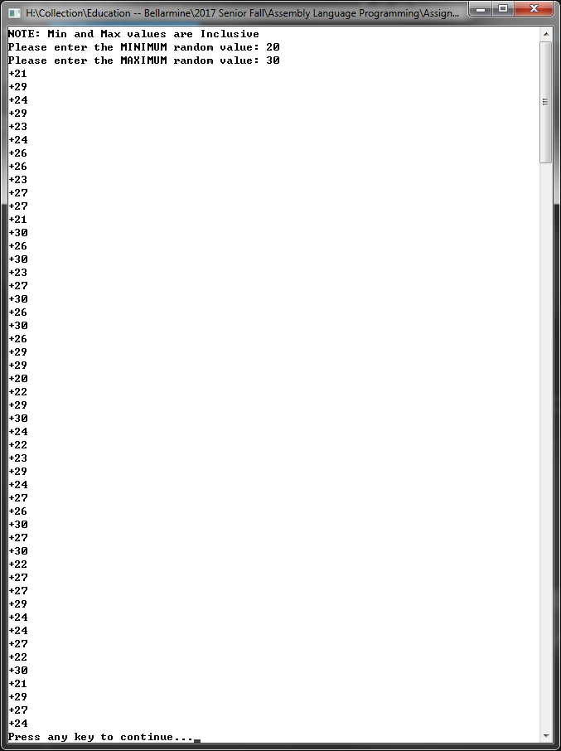

Exercise 9: Recursive Procedure

The Recursion procedure in the program calls itself again if ecx does not equal 0. The value of eax is incremented once each time Recursion is called and then printed.

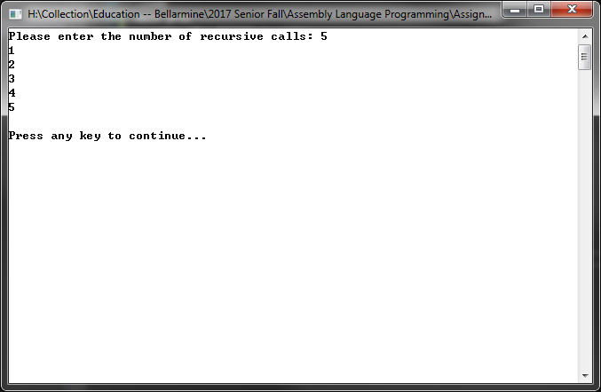

Exercise 10: Fibonacci Procedure

As the exercise specified, I asked for the value of the 47th Fibonacci number which matched the expected value of 2971215073. The first value in the array matched the expected value of 1.

This screenshot below shows the values in the array after pushing the 47th number.

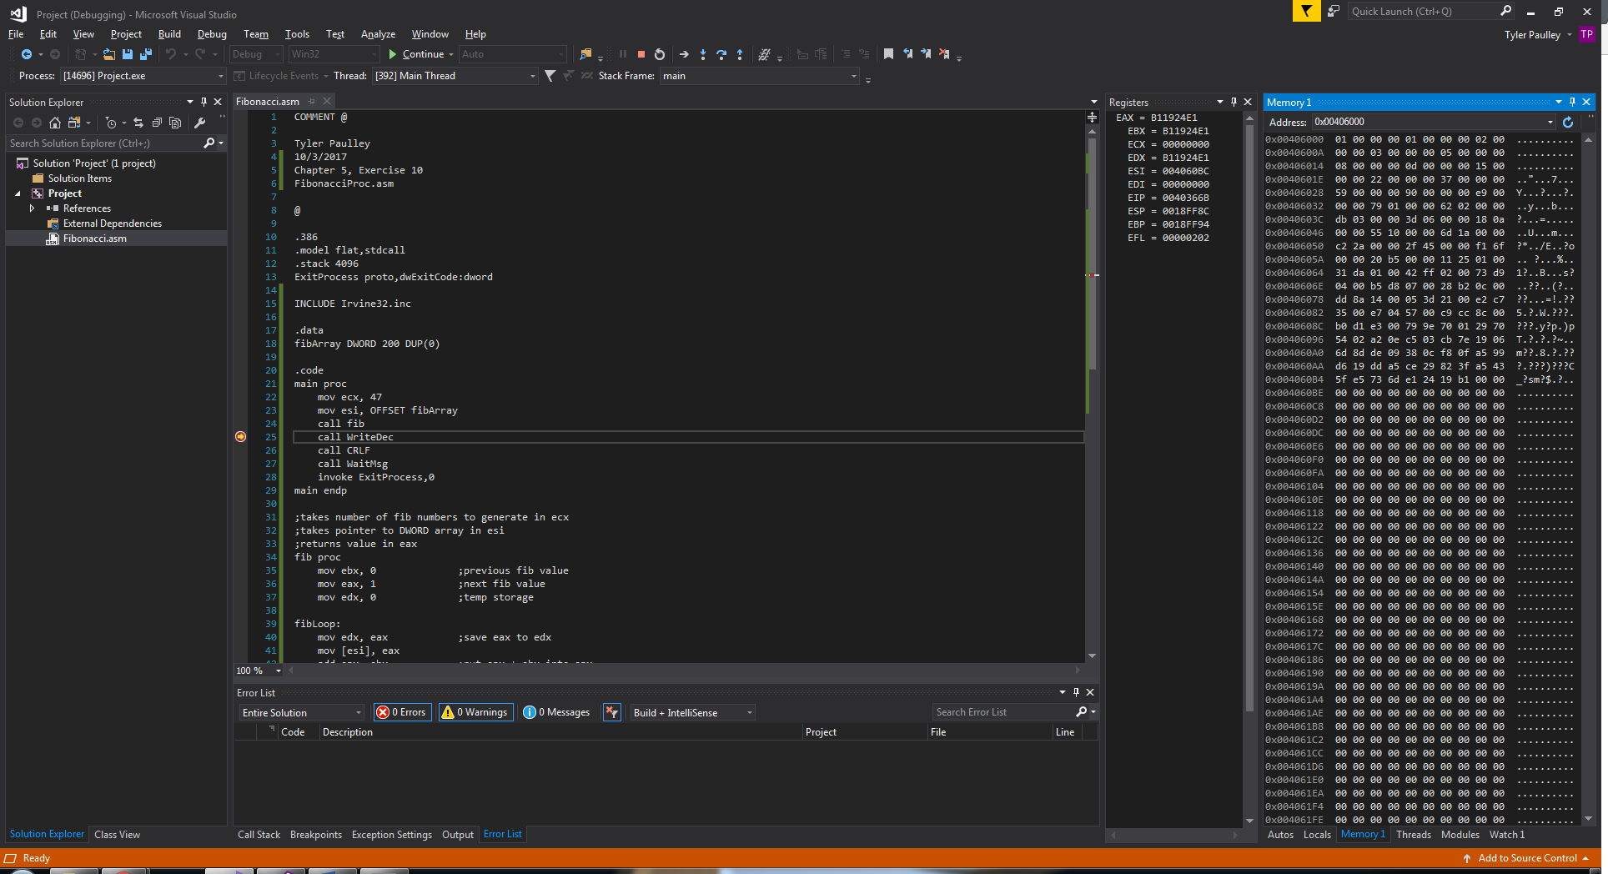

The program prints the final value pushed into the array which is 2971215073 as the prompt specified. This value is located at EAX.

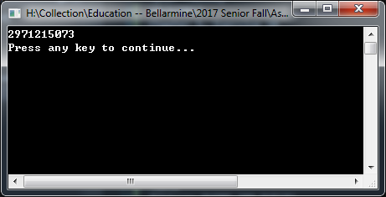

The first value pushed into the array from EAX is 1 as the prompt specified.

